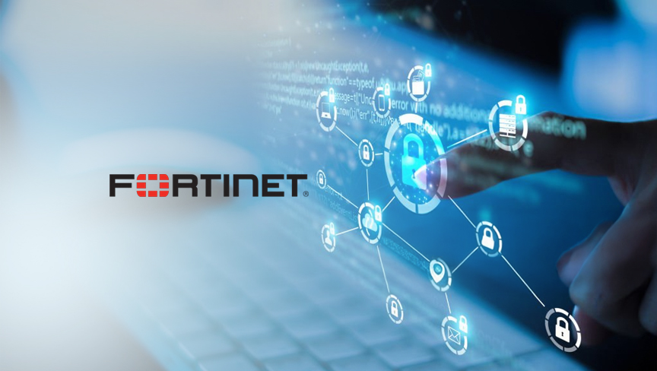

SOHO Configuration (Fortigate)
By: Marvin Boonnantakul

Purpose: The purpose of this lab is to configure a small Office/Home Office or “SOHO” network in a Fortinet FortiGate 40F firewall. This lab provides a better understanding of how to securely connect devices, and segment network traffic in a real-world environment. Including the configuration of access controls, and the security of traffic flow to protect the internal devices from any external threats

Background Information on lab concepts: A SOHO configured network is created for small environments, from homes to small businesses that require secure internet connectivity without a large network enterprise. The SOHO network is configured to provide secure internal communication towards multiple devices, including computers, printers, phones, or any servers or wireless devices while still having secure external internet usage. Due to the constant internet connection, securing the network traffic and components is significantly important to the networks design to help reduce any unauthorized users, malware, or any outside attack that could gain access to the internal sensitive information/devices.
Through the FortiGate 40F the firewall acts as the main Layer 3 security device. The firewall is made to filter and control the traffic of the network. In contrast to a regular home router, The Fortigate firewall provide a more significant security including, firewall polices, Network Address Translation (NAT), VLAN support, traffic logging, or scheduled access control. The firewall act as a central point between the networks as a internal trust and the external untrust internet connection, which will help prevent any unauthorized access during any real legitimate traffics.
Furthermore, the Local Area Network (LAN) inside the firewall configuration is configured to allow trusted internal devices to help communicate with any organization/ home environments. These trusted devices are typically made to further connect with its internal switch ports or VLANs of the firewall as well. Additionally when the Wide Area Network (WAN) is connected with the Internet Service Provider (ISP) modem, the network will be given access to the network, where the firewall is made to separate these zones through its security polices to determine access and denial to traffics between the LAN and WAN, significantly improving the security by keeping the eternal devices from the internet, unless permitted by firewall rules.
Lab Summary: In this lab, SOHO network was configured with the FortiGate 40F firewall by setting the appropriate defensive firewall policies to manage traffic between the LAN and external networks. An implementation that was set to improve security was setting a schedule on the network for specific time to operate only during class hours to help reduce any extra unnecessary exposure to any attacks. Furthermore, additional policies would be added to allow only traffic from the LAN, blocking any incoming connections from the outside while still allowing the internal devices to access external usage. In contrast to the Palo Alto firewall where the SOHO setup requires more setup due to its application and users’ identification than just the IP address itself, requiring zone configurations.
Problems:

Lab Commands: N/A
Configurations:
Network Diagram with IP’s:
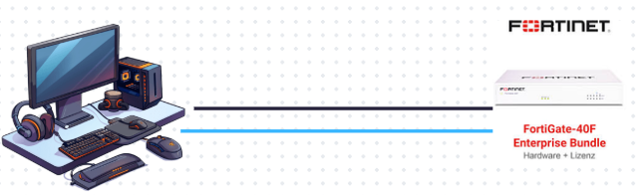
Conclusion: This lab illustrates the extra secure steps that can be configured into the fortigate firewall’s SOHO network which can highly secure the network significantly more than its default settings. By using the Fortinet FortiGate 40F firewall on this lab, my lab partner and I implimented a scheduled access policy on to the firewall to reduce the amount of time the network will be exposed, decreasing the chances of attacks when the system isn’t actively being used. Furthermore, the restriction of the sources of the traffic to the LAN allowing connections from all sources that would prevents unauthorized external access while still maintaining the normal outbound connectivity from the internal users. These configurations can also be seen in real world security operations to prove the most minimal exposure and limiting trust boundaires to ensure a safe network. Overall, this lab highlights the importance in not just the right hardware but as well as its configuration choices to help reduce attacks and its vulnerabilities to protect its network from exterior threats.
Screenshots:
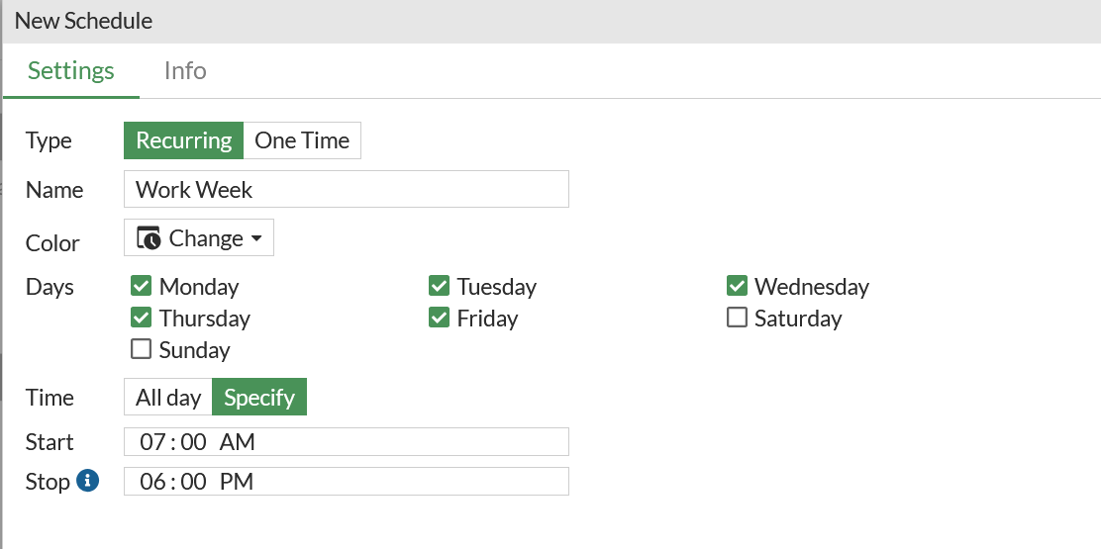
The Fortigate 40F schedule on policies and SSIDs is set for the firewall to not interfere with other broadcasted SSIDs.
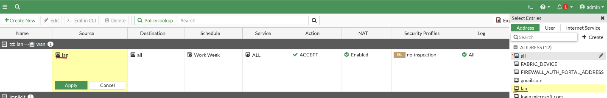
The firewall will only permit LAN to access things and will block any outside source from trying to access the LAN by changing the source from all to only lan.
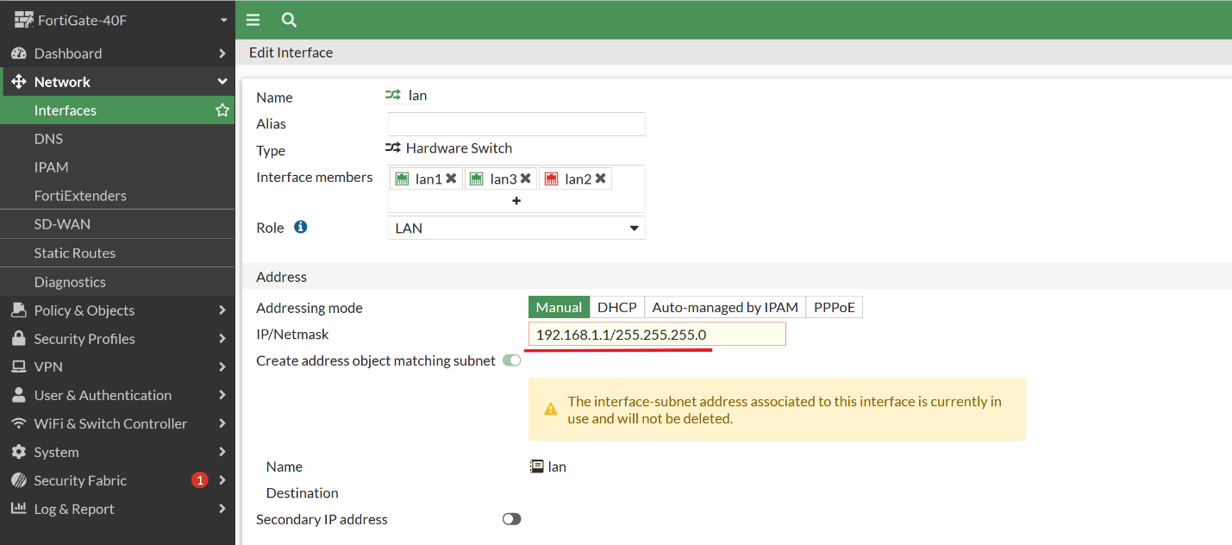
When the management IP from 192.168.1.99 is changed it makes it less likely that someone will be able to gain access to the firewall’s GUI interface.

Sign off: 